**ARTIFICIAL INTELLIGENCE   
LAB REPORT**



LAB REPORT SUBMITTED TO

**BIPIN TIMALSINA**

**PATAN MULTIPLE CAMPUS**

**INSTITUTE OF SCIENCE AND TECHNOLOGY**

BY

**SURAB PARAJULI**

CAMPUS ROLL No: 34

SYMBOL No: 80010139

4th sem - ‘A’

**____________, 2025**

Table Of Contents

LAB 1 : BASIC LINUX COMMANDS 1

1. ls 1

2. dir 1

3. ls -a 1

4. ls -l 1

5. ls -lh 2

6. ls -F 2

7. ls -r 3

8. ls -R 3

9. ls -ltr 4

10. ls -i 4

11. ls --version 4

12. ls --help 5

13. ls -n 5

14. clear 5

15. mkdir 6

16. cd 6

17. touch 6

18. text editing 7

19. [bc]at 8

20. > 8

21. touch file1 file2 ... 9

22. cp 9

23. cd .. 9

24. pwd 10

25. cp <file_src> <file_dest> 10

26. mv 11

27. rm 11

28. rmdir 12

29. rm -rf 12

LAB 2 : INTERMEDIATE LINUX COMMANDS 13

1. lscpu 13

2. [sudo] lshw 14

3. hwinfo [--short] 15

4. lspci 17

5. lsscsi 17

6. lsusb 18

7. inxi [-f][-F][-x] 19

8. lsblk 20

9. df 20

10. pydf 21

11. fdisk [-l] 21

12. free 22

13. dmidecode [-t <type>] 22

14. cat /proc/meminfo 25

15. cat /proc/version 25

16. hdparm [-i </dev/sata_device>] 25

17. uname [-n] [-r] 26

18. factor 26

19. bc 27

20. id 27

21. shutdown 28

22. ping 29

23. netstat [-r] 29

24. tcpdump 31

25. host google.com 31

26. tracepath achsnepal.edu.np 32

27. ifconfig 32

28. route 33

29. nslookup 33

30. whois 34

[31. pacman [-S[yy][u]] [package_name] 35](#_Toc205141449)

32. sl 36

33. sudo -s 36

34. exit 36

LAB 3 : BASH SCRIPTING 37

1. basic scripting 37

2. Input 38

3. Square 38

4. Branching 39

5. for-loop 40

6. while-loop 41

7. directory manipulation 42

8. while-dir 43

9. commands 44

10. system update 45

LAB 4 : PROCESSES 46

1. print 46

2. fork 47

3. pid 48

4. execute 49

LAB 5 : THREADS 50

1. basic 50

2. multi-thread 51

3. thread-process 53

4. thread-arguement 54

LAB 6 : SCHEDULING 56

1. Algorithms 56

LAB 1 : BASIC LINUX COMMANDS

# ls

Interpretation: List information about the FILEs (the current directory by default)

Output:

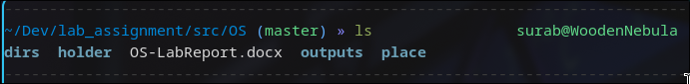

# dir

Interpretation: List information about the FILEs (the current directory by default)

Output:

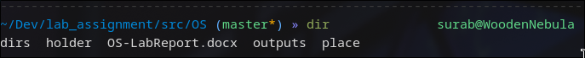

# ls -a

Interpretation: Lists contents and do not ignore entries starting with .

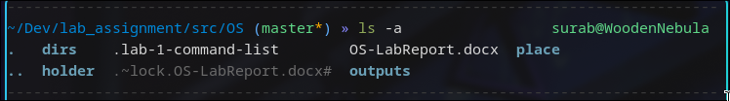Output:

# ls -l

Interpretation: use a long listing format

Output:

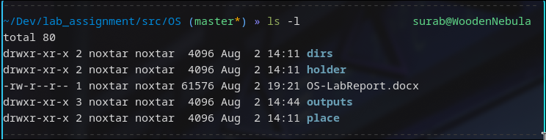

# ls -lh

Interpretation:

Lists contents along with human readable size formats

Output:

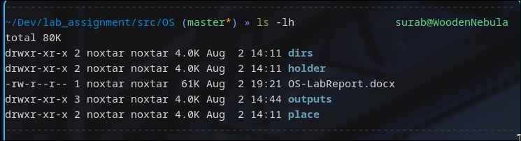

# ls -F

Interpretation: append indicator (one of */=>@|) to entries WHEN

Output:



# ls -r

Interpretation: reverse order while sorting

Output:

# ls -R

Interpretation: recursively list the directories

Output:

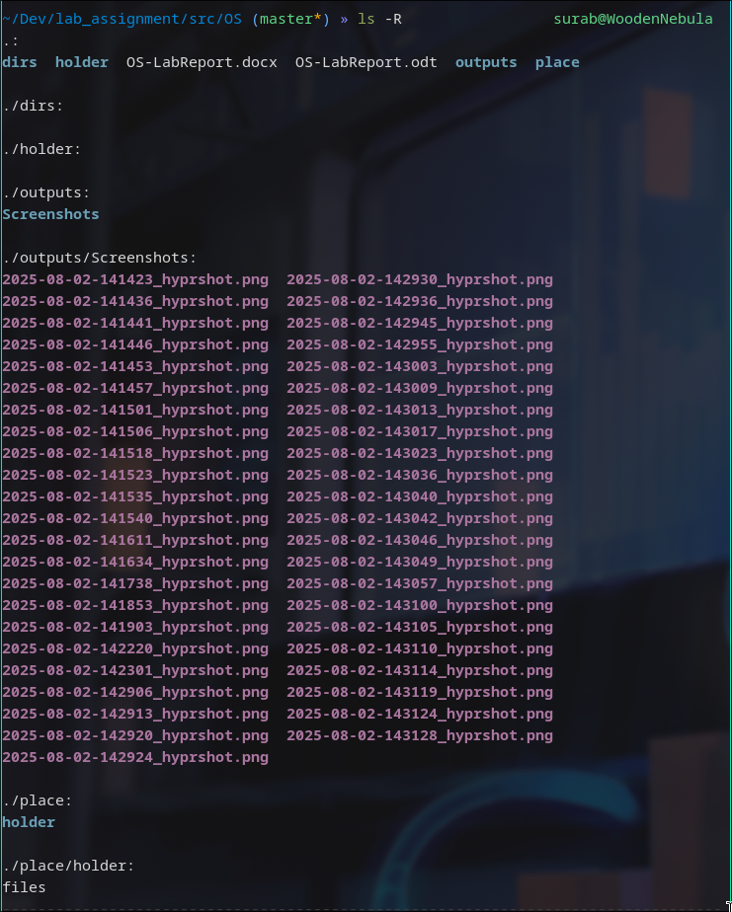

# ls -ltr

Interpretation: Lists contents in long listing sorted by time in reverse(oldest first) order

Output:

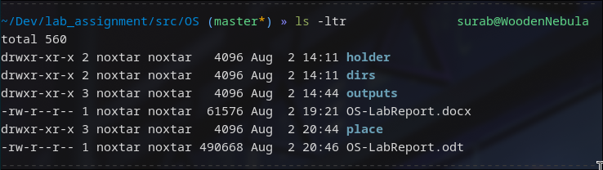

# ls -i

Interpretation: print the index number of each file

Output:

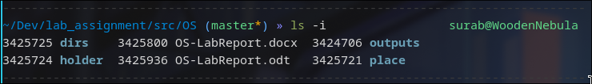

# ls --version

Interpretation: output version information and exit

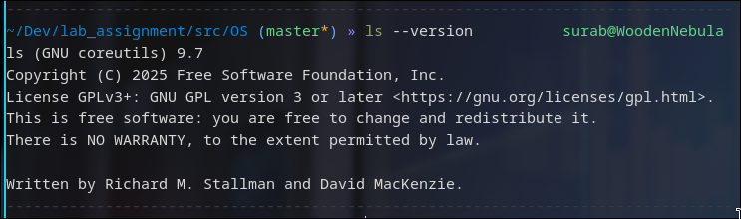Output:

# ls --help

Interpretation: displays man/help page for the command ls

Output:

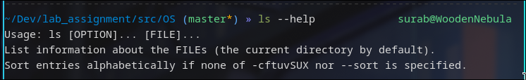

# ls -n

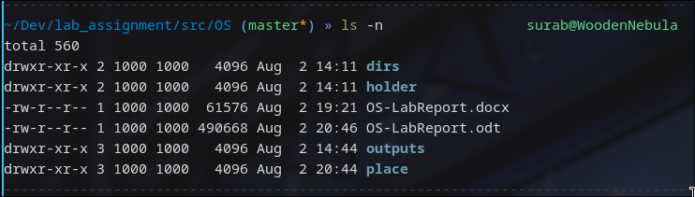Interpretation: like -l, but list numeric user and group IDs

Output:

# clear

Interpretation: clears the terminal screen to default prompt

Output:

# mkdir

Interpretation: creates a directory with the provided name in current or supplied directory

Output:

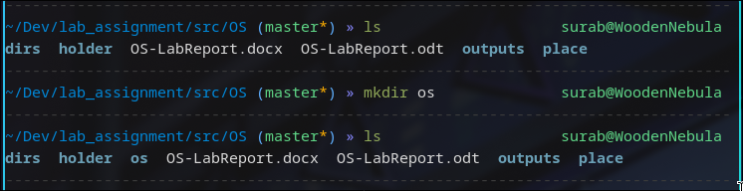

# cd

Interpretation: changes current directory to the supplied directory

Output:

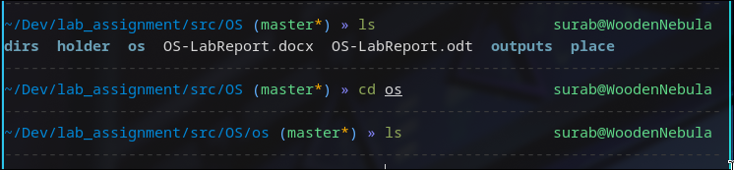

# touch

Interpretation: Updates the access and modification times of each FILE to the current. As a side effect, it creates the FILE if it doesn’t exist yet

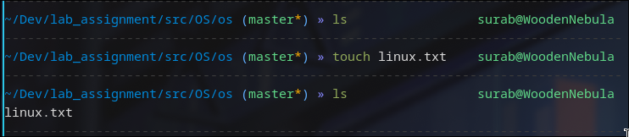Output:

# text editing

Command: nano/vi/vim/nvim text-file

Interpretation: opens the text-file with the specific terminal based text editor

Output:



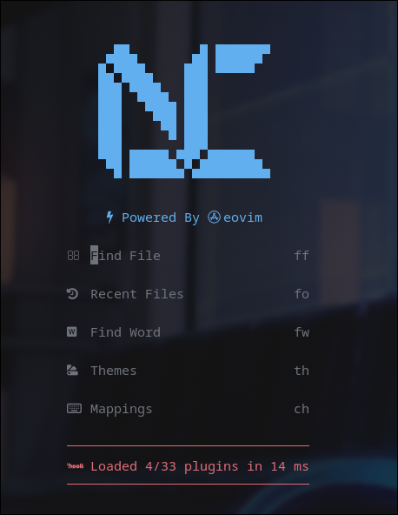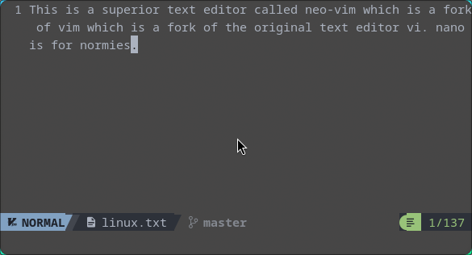

# [bc]at

Command: bat/cat

Interpretation: concatenate files and print on the standard output

Output:

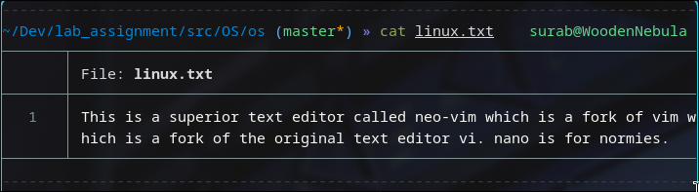

# >

Command: command > file

Interpretation: redirects the input from the command or stdin to the supplied file

Output:

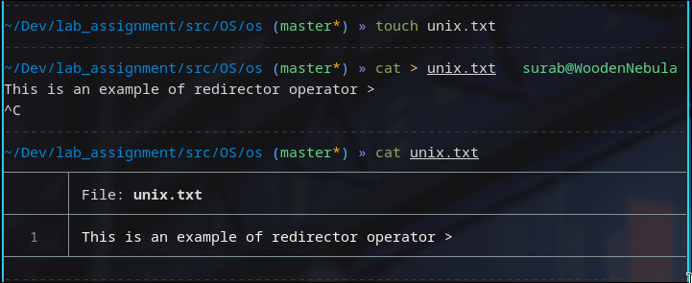

# touch file1 file2 ...

Interpretation: touches multiple supplied files

Output:

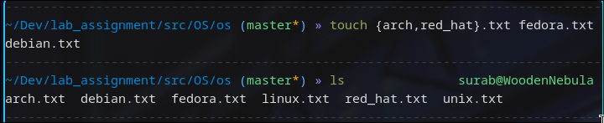

# cp

Command: cp <source> <dest>

Interpretation: copies content from source to destination

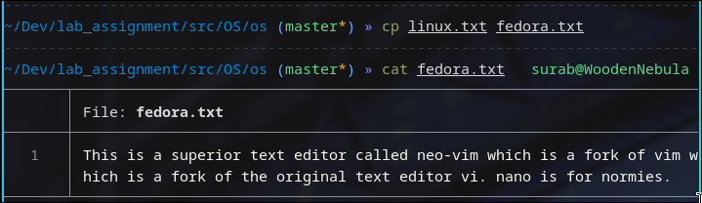Output:

# cd ..

Interpretation: goes up a directory in current dir-tree

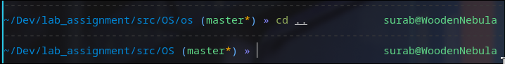Output:

# pwd

Interpretation: prints current working directory

Output:

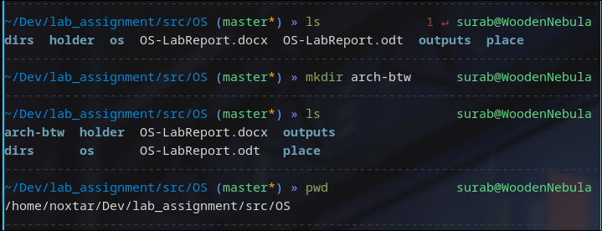

# cp <file_src> <file_dest>

Interpretation: Copies file from provided source to destination

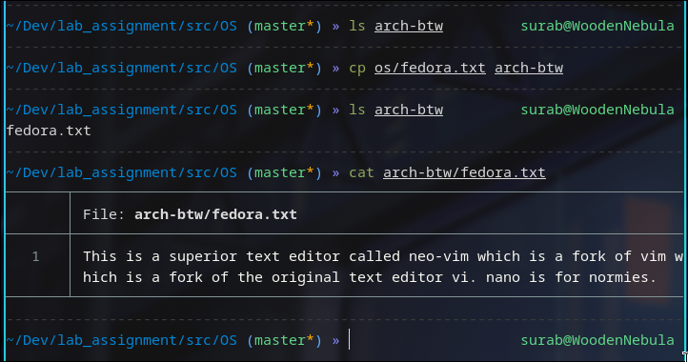Output:

# mv

Interpretation: moves file from source to destination

Output:

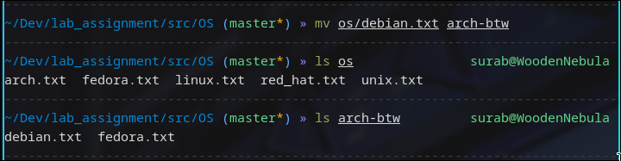

# rm

Command: rm <file1> <file2> ...

Interpretation: removes file at provided paths, wildcards can be used to pattern match as well for removing multiple files

Output:

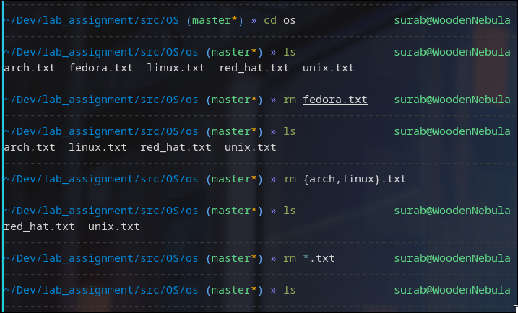

# rmdir

Command: rmdir <dir>

Interpretation: removes empty directory at supplied directory

Output:

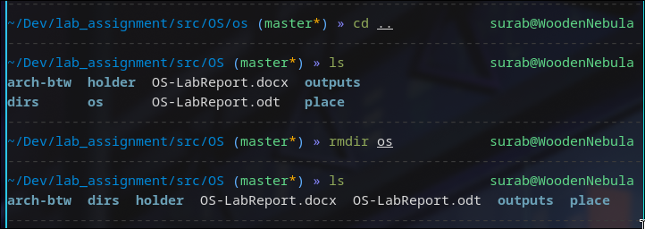

# rm -rf

Interpretation: remove supplied directory recursively and forcefully

Output:

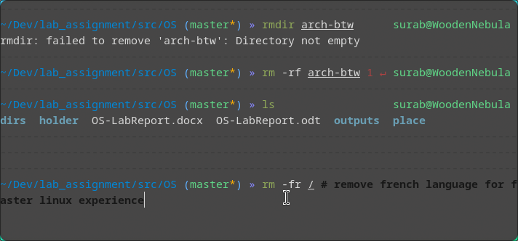

LAB 2 : INTERMEDIATE LINUX COMMANDS

# lscpu

Interpretation: lscpu gathers CPU architecture information from sysfs, /proc/cpuinfo and any applicable architecture-specific libraries. The information includes, the no. of CPUs, threads, cores, sockets, and NUMA nodes. There is also information about the CPU caches and cache sharing, family, model, bogoMIPS, byte order, and stepping.

Output:

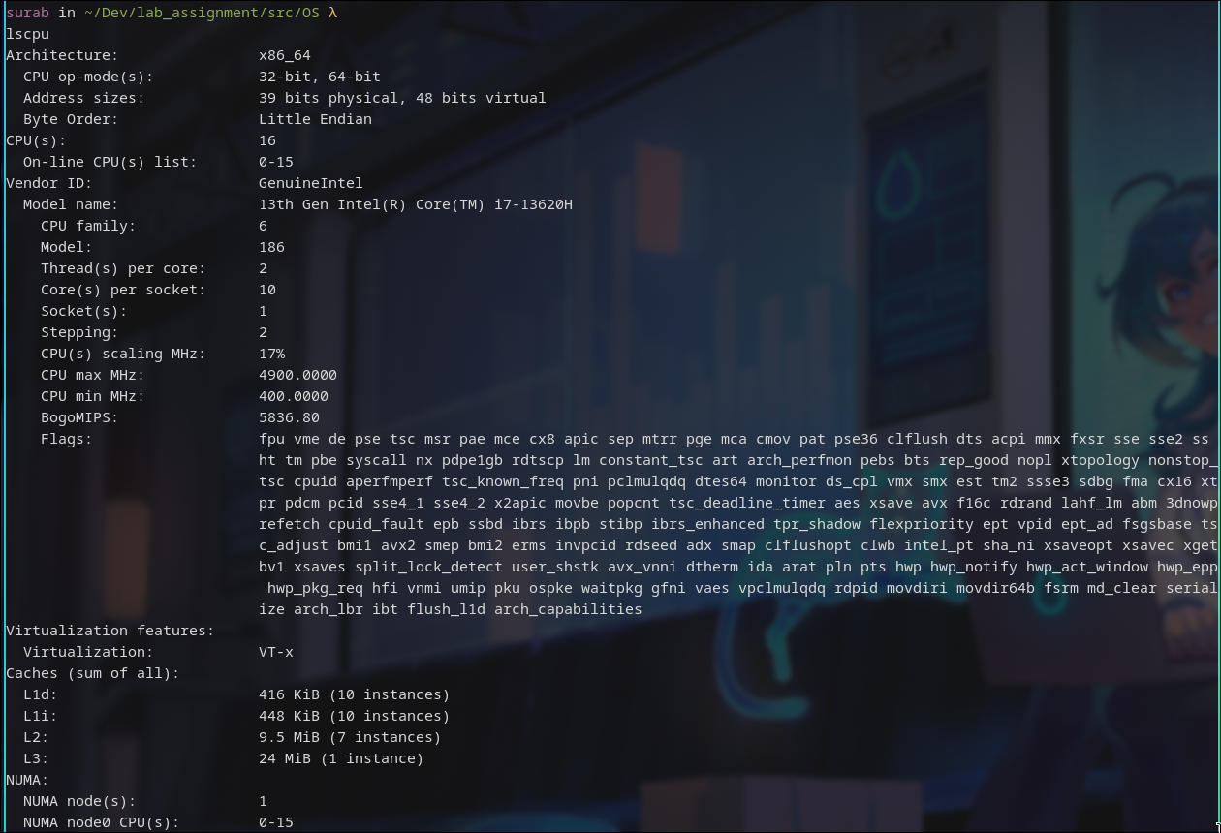

# [sudo] lshw

Interpretation: lshw is a small tool to extract detailed information on the hardware configuration of the machine. It can report exact memory configuration, firmware version, mainboard configuration, CPU version and speed, cache configuration, bus speed, etc. on DMI-capable x86 or IA-64 systems and on some PowerPC machines (PowerMac G4 is known to work).

Output:

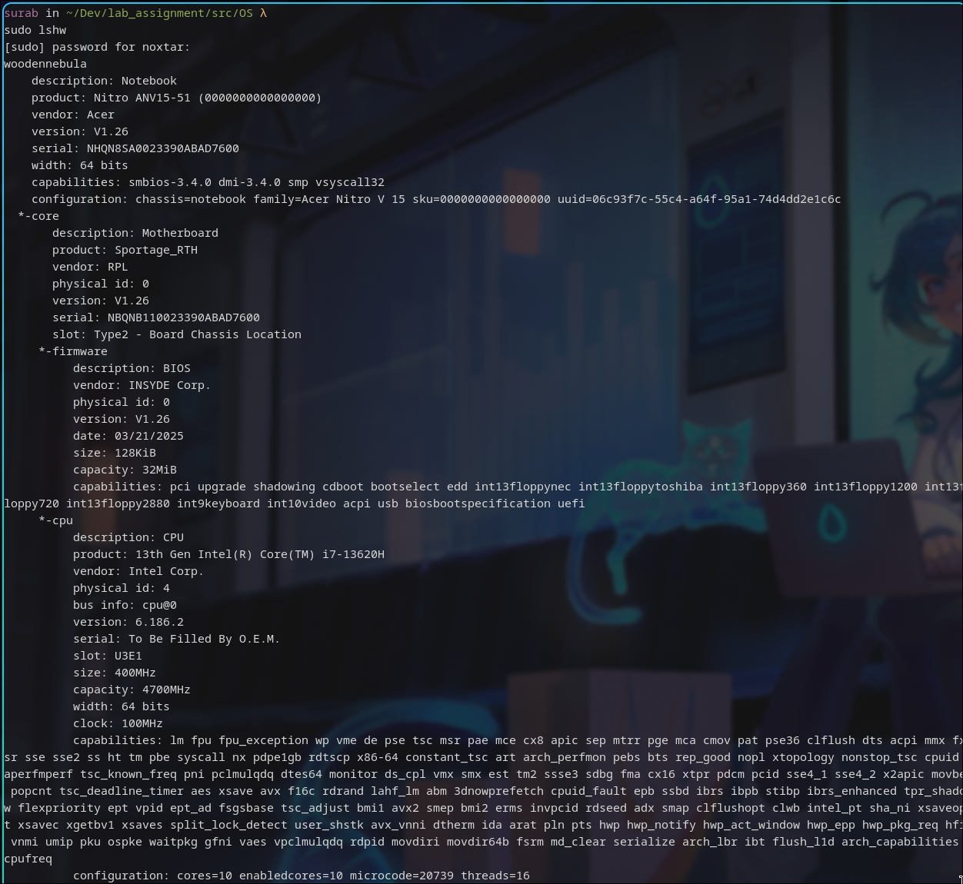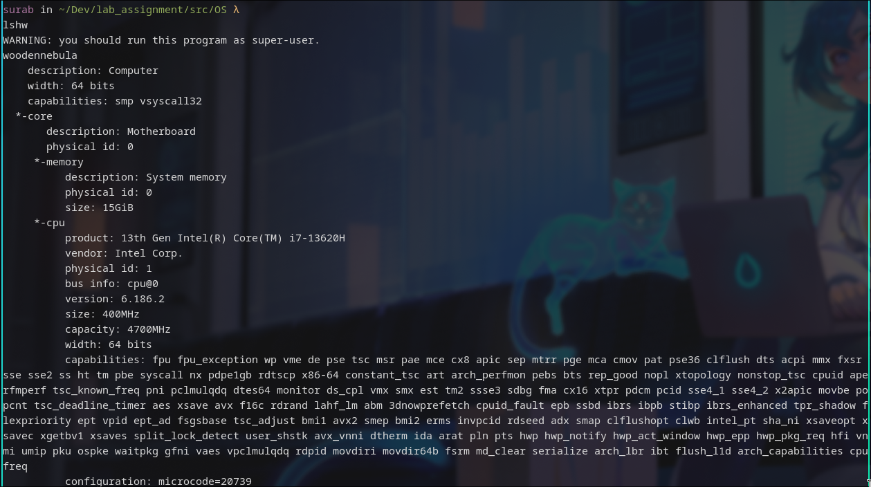

# hwinfo [--short]

Interpretation: hwinfo is used to probe for the hardware present in the system. It can be used to generate a system overview log which can be later used for support.

Output:

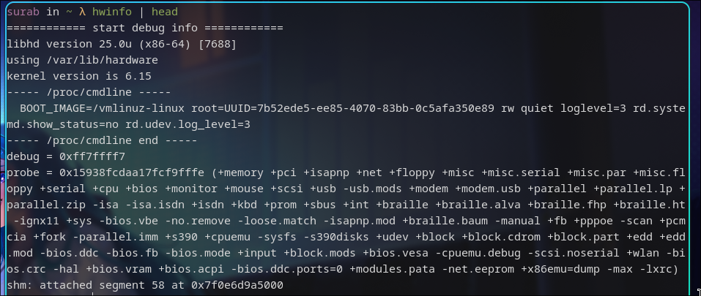

Command: hwinfo --short

Interpretation: Show only a summary.

Output:

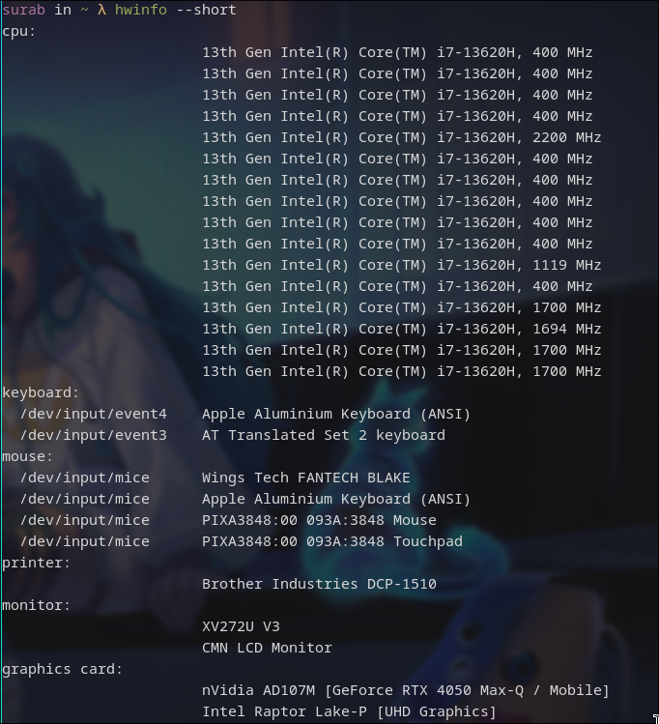

# lspci

Interpretation: lspci is a utility for displaying information about PCI buses in the system and devices connected to them.

Output:

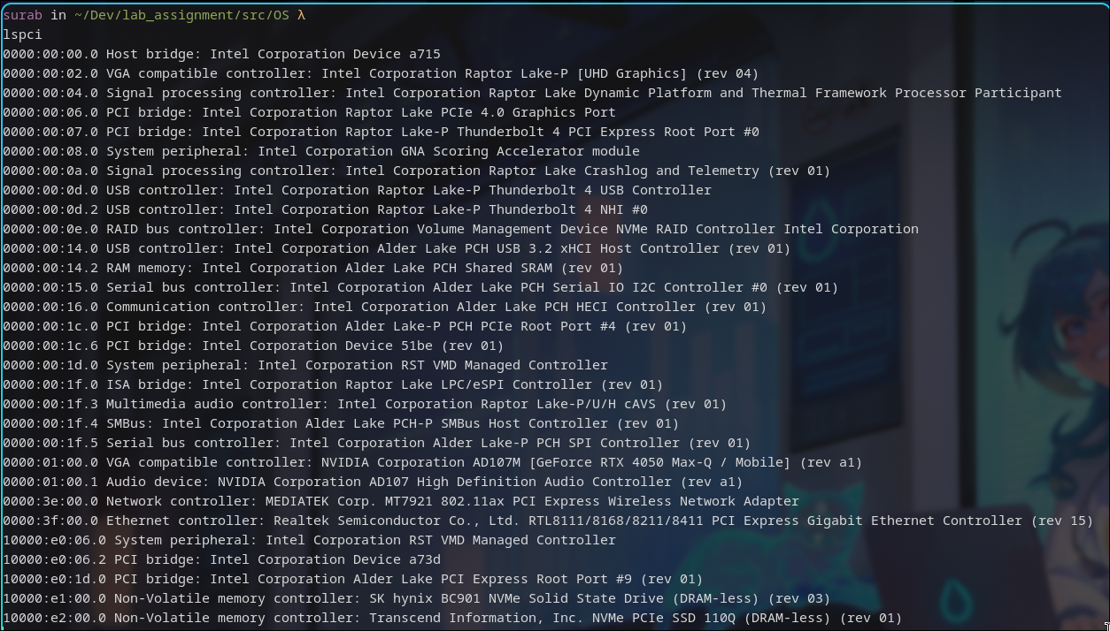

# lsscsi

Interpretation: Uses information in sysfs to list SCSI devices (or hosts) currently attached to the system. Many non-SCSI storage devices (but not all) used the SCSI subsystem in Linux.

Output:

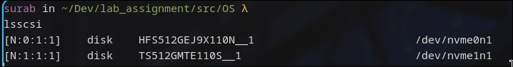

# lsusb

Interpretation: lsusb is a utility for displaying information about USB buses in the system and the devices connected to them. It uses udev's hardware database to associate a full human-readable name to the vendor ID and the product ID.

Output:

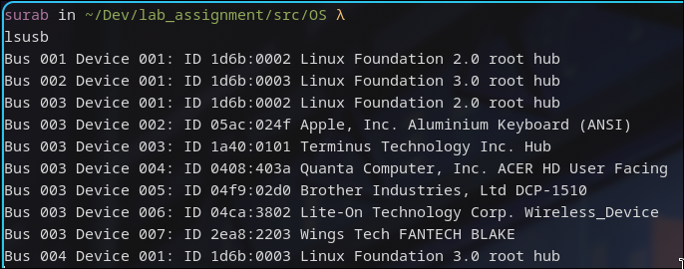

Command: lsusb | tee lsusb.txt  
Interpretation: print each line and write to a file named lsusb.txt



# inxi [-f][-F][-x]

Interpretation: Command line system information tool for console and IRC

Output:

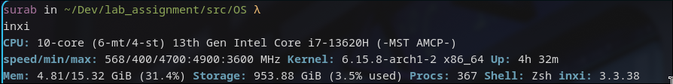

Command: inxi -fx  
Interpretation: Lists all cpu flags used

Output:

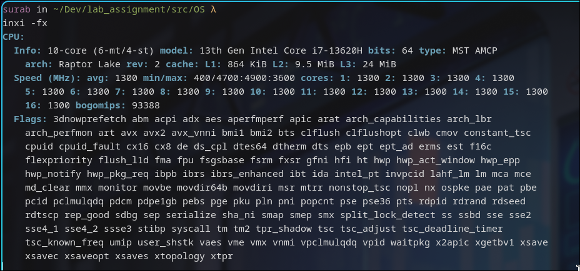

Command: inxi -Fx  
Interpretation: Lists expanded basic CPU data line

Output:

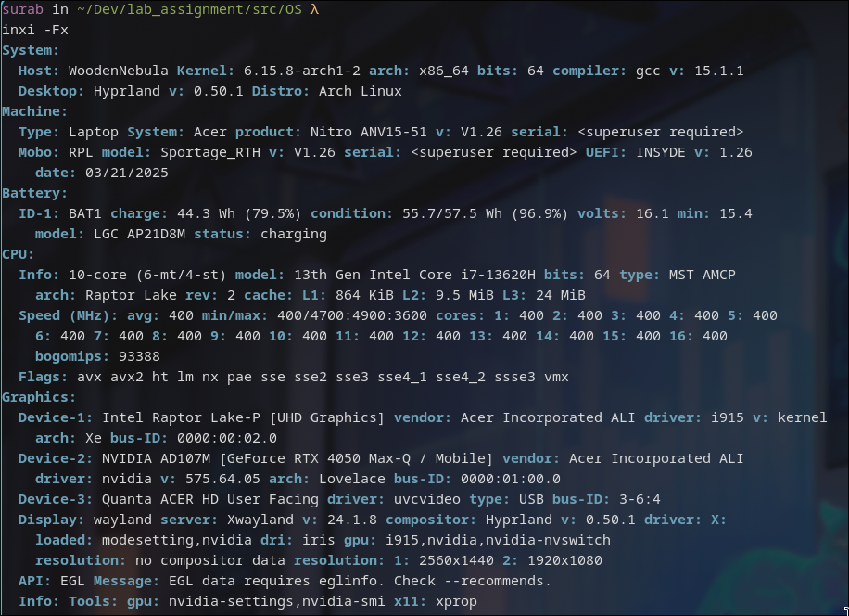

# lsblk

Interpretation: lists information about all available or the specified block devices. The lsblk command reads the sysfs filesystem and udev db to gather information.

Output:

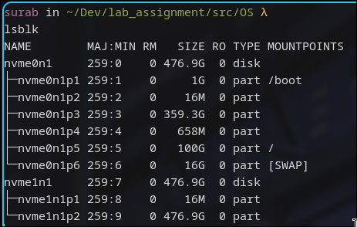

# df

Interpretation: report file system space usage

Output:

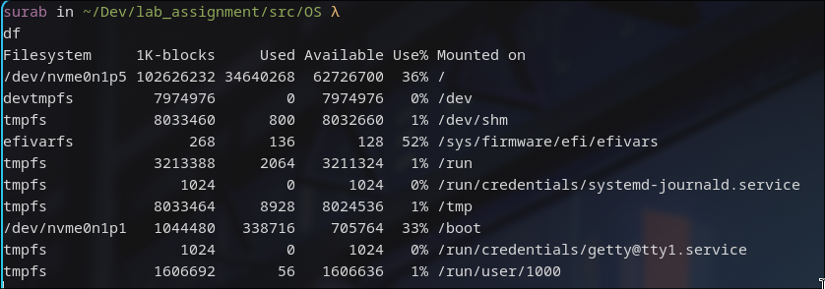

# pydf

Interpretation: ydf is a python script that displays the amount of disk space available on the mounted filesystems, using different colours for different types of filesystems. Output format is completely customizable.

Output:

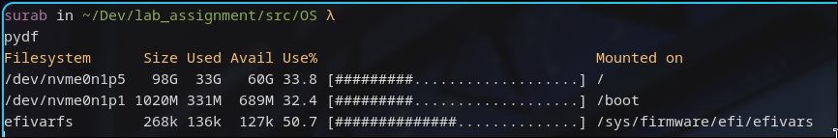

# fdisk [-l]

Interpretation: fdisk is a dialog-driven program for creation and manipulation of partition tables. It understands GPT, MBR, Sun, SGI and BSD partition tables.

Output:

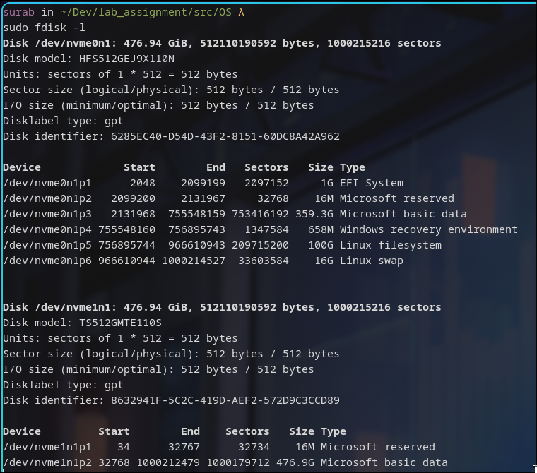

# free

Interpretation: free displays the total amount of free and used physical and swap memory in the system, as well as the buffers and caches used by the kernel. The information is gathered by parsing /proc/meminfo

Output:

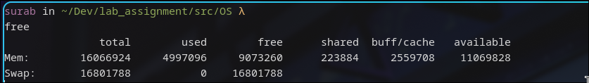

# dmidecode [-t <type>]

Interpretation: dmidecode is a tool for dumping a computer's DMI (SMBIOS) table contents in a human-readable format. This table contains a description of the system's hardware components from which we can retrieve this information without having to probe for the actual hardware.

-t <type> option makes it to only display information for the supplied device type.

Command: sudo dmidecode -t processor

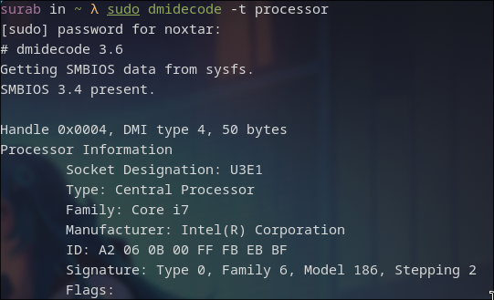Output:

Command: sudo dmidecode -t memory

Output:

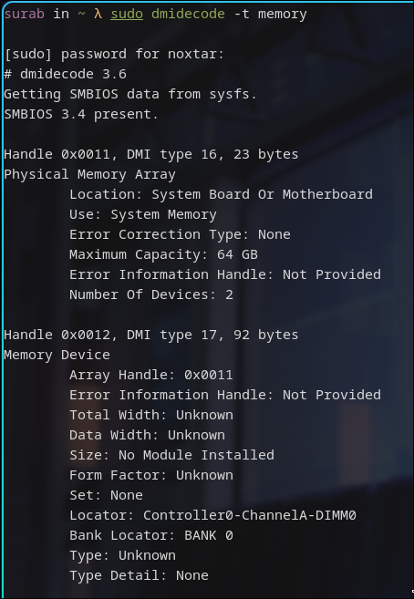

Command: sudo dmidecode -t bios

Output:

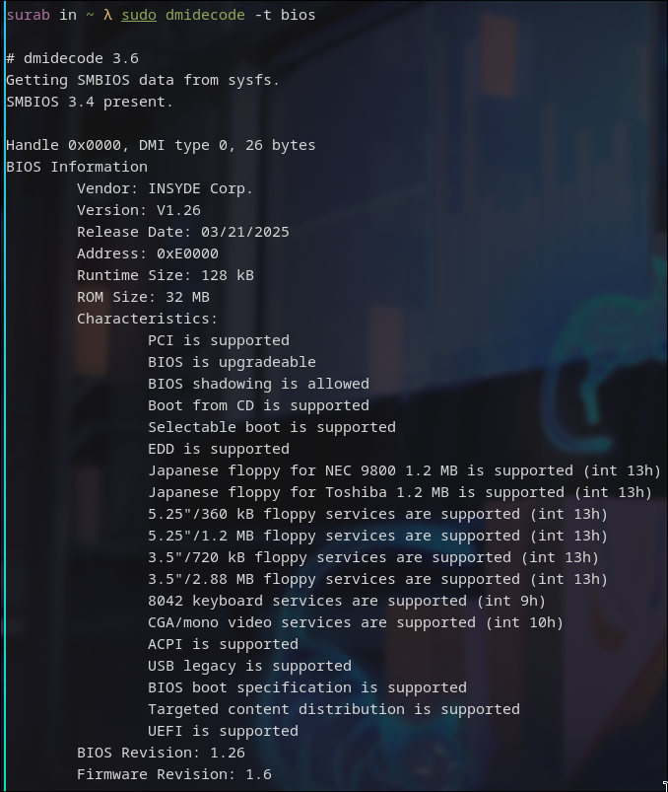

# cat /proc/meminfo

Interpretation: reads file /proc/meminfo and output the various information of memory segments of the computer system.

Output:

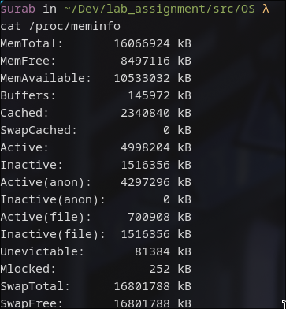

# cat /proc/version

Interpretation: displays the system information in quick summary

Output:



# hdparm [-i </dev/sata_device>]

Interpretation: Displays the identification info which the kernel drivers (IDE, libata) have stored from boot/configuration time for the SATA/IDE device

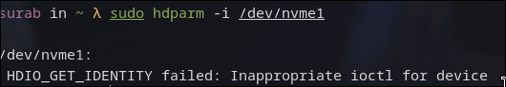Note: My laptop only has NVMe drives, so the command failed

# uname [-n] [-r]

Interpretation: print system information

-n: print the network node hostname

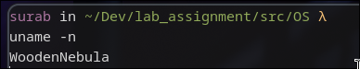

-v: print the kernel version

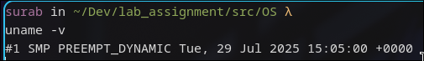

-r: print the kernel release

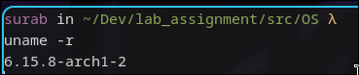

-m: print the machine hardware name

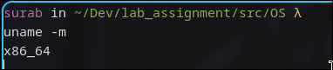

-a: print all the information



# factor

Interpretation: Print the prime factors of each specified integer NUMBER. If none are specified on the command line, read them from standard input.

Output:

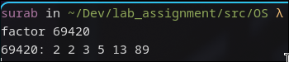

# bc

Command: echo ‘3*9’ | bc

Interpretation: bc is an arbitrary precision calculator language. The expression 3*9 is piped into bc as input to calculate for output.

Output:

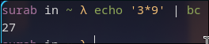

# id

Interpretation: print real and effective user and group IDs

Output:



# shutdown

Interpretation: Halt, power off or reboot the machine, with no params, it shutsdown after 1 minute

Command: shutdown now

Interpretation: Immediately shutdown the machine

Command: shutdown 13:20

Interpretation: Shutdown the machine at 13:20 O’ clock

Command: shutdown 10

Interpretation: Shutdown the machine after 10 mins have elapsed after the command triggers

Command: shutdown -r +10

Interpretation: Restart the machine after 10 mins have elapsed after the command triggers

Command: shutdown -c

Interpretation: Cancel any pending shutdown

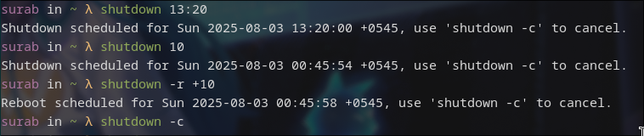

# ping

Command: ping -w3 google.com

Interpretation: send ICMP ECHO_REQUEST to google.com for 3 seconds.

Output:

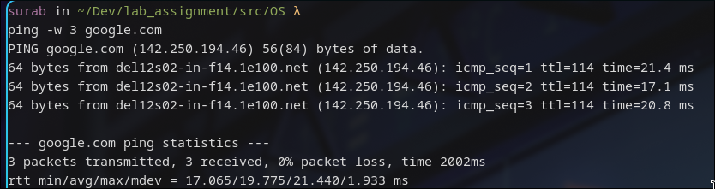

# netstat [-r]

Interpretation: Print network connections, routing tables, interface statistics, masquerade connections, and multicast memberships.

Output:

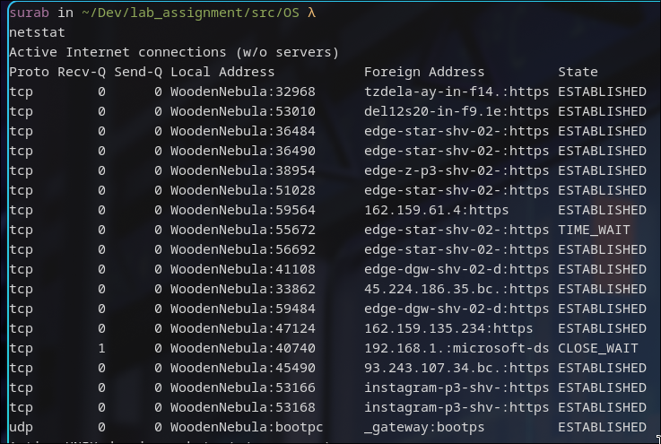

Command: netstat -r   
Interpretation: display kernel routing tables

Output:

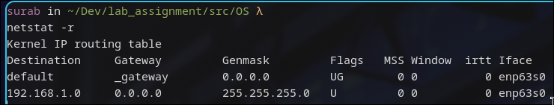

Command: netstat -p   
Interpretation: Show the PID and name of the program to which each socket belongs. A hyphen is shown if the socket belongs to the kernel

Output:

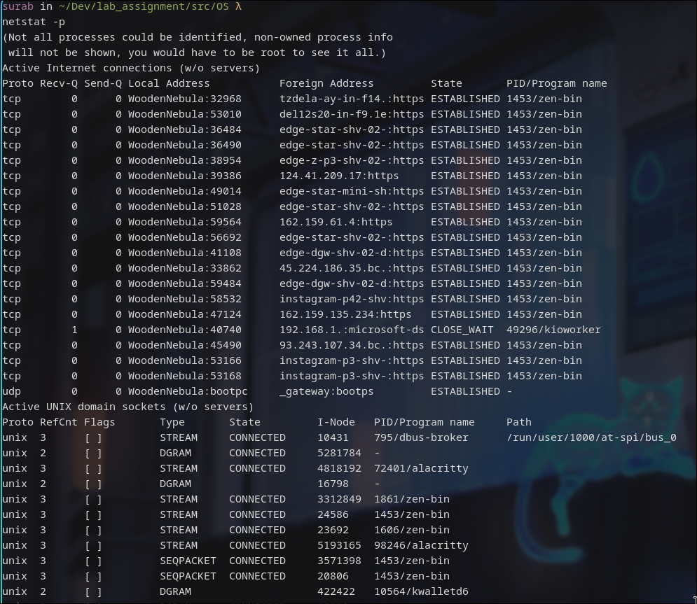

# tcpdump

Interpretation: dump traffic on a network.

Output:

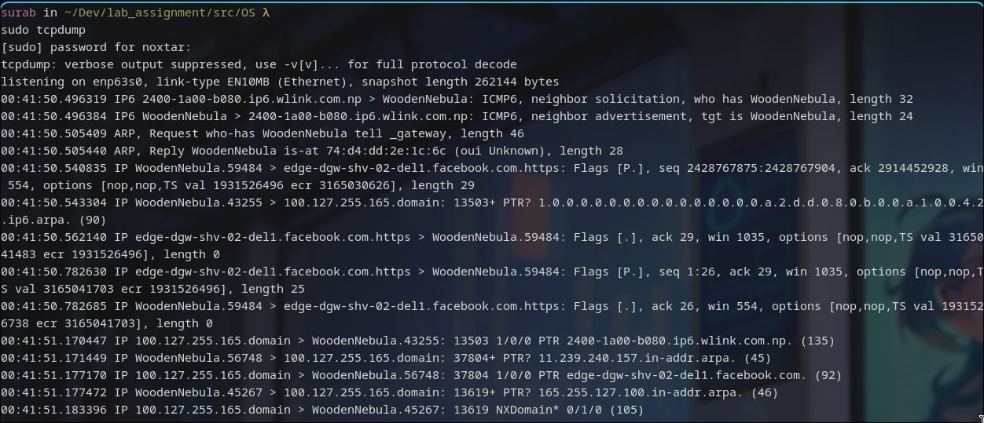

# host google.com

Interpretation: host is a simple utility for performing DNS lookups. It is normally used to convert names to IP addresses and vice versa.

Output:

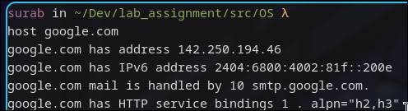

# tracepath achsnepal.edu.np

Interpretation: It traces the network path to destination discovering MTU along this path. It uses UDP port port or some random port. It is similar to traceroute.

Output:

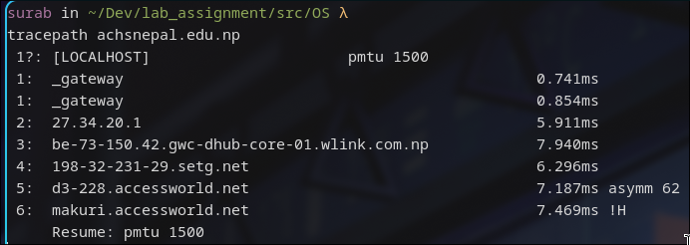

# ifconfig

Interpretation: Ifconfig is used to configure the kernel-resident network interfaces. It is used at boot time to set up interfaces as necessary. After that, it is usually only needed when debugging or when system tuning is needed.

Output:

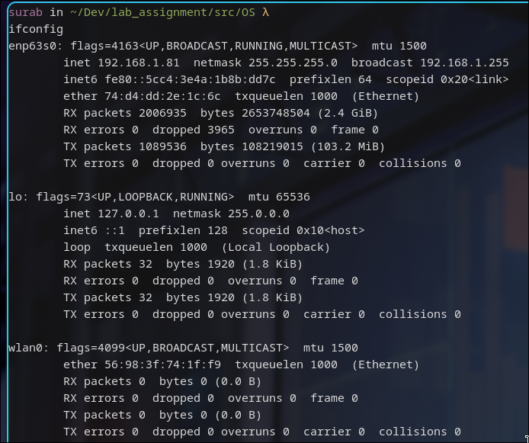

# route

Interpretation: Route shows/manipulates the kernel's IP routing tables.

Output:

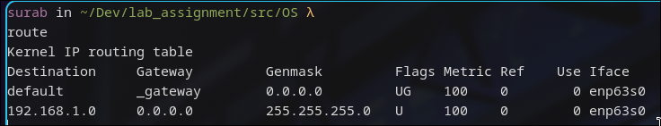

# nslookup

Interpretation: nslookup is a program to query Internet domain name servers. nslookup has two modes: interactive and non-interactive. Interactive mode allows the user to query name servers for information about various hosts and domains or to print a list of hosts in a domain. Non-interactive mode prints just the name and requested information for a host or domain.

Output:

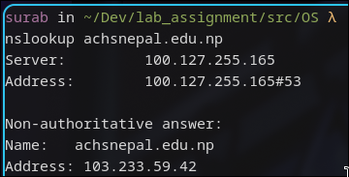

# whois

Interpretation: whois searches for an object in a RFC 3912 database.

Output:

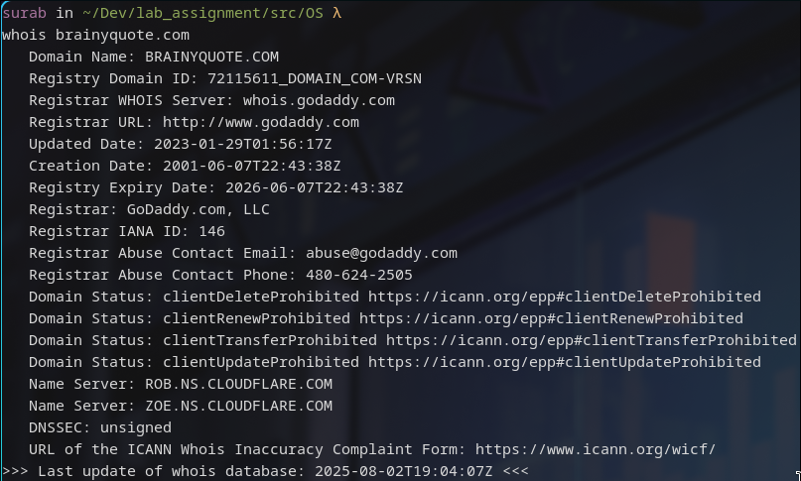

# pacman [-S[yy][u]] [package_name]

pacman is a package manager for arch based distros. It does similar work to apt-get for debian based.

Command: pacman -Syyu

Interpretation: force sync local package cache database and update them

Output:

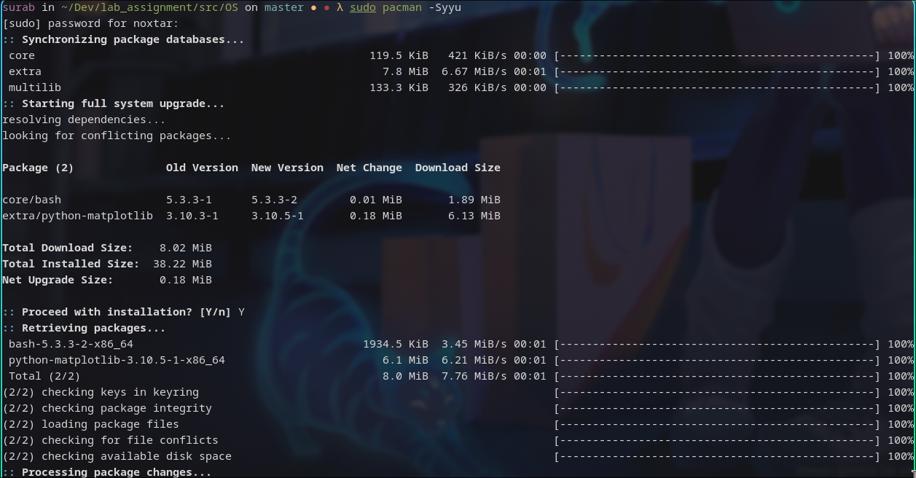Command: pacman -S sl

Interpretation: Searches for a package named sl and installs it if not already installed

Output:

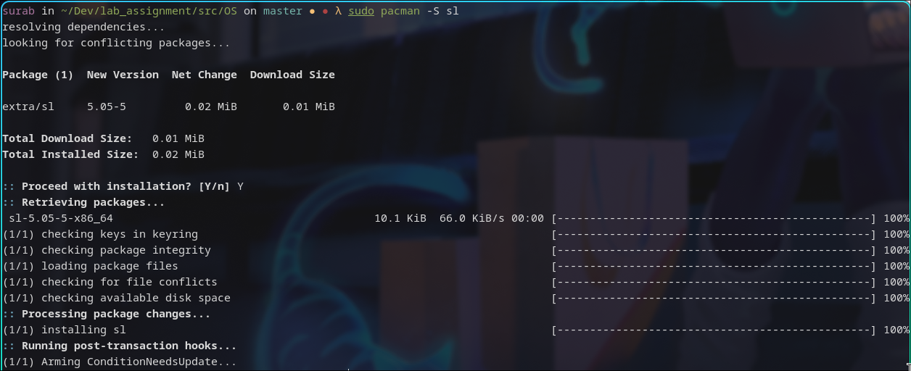

# sl

It is one of many easter egg commands in linux. This one is for typo of ls command.

Output:

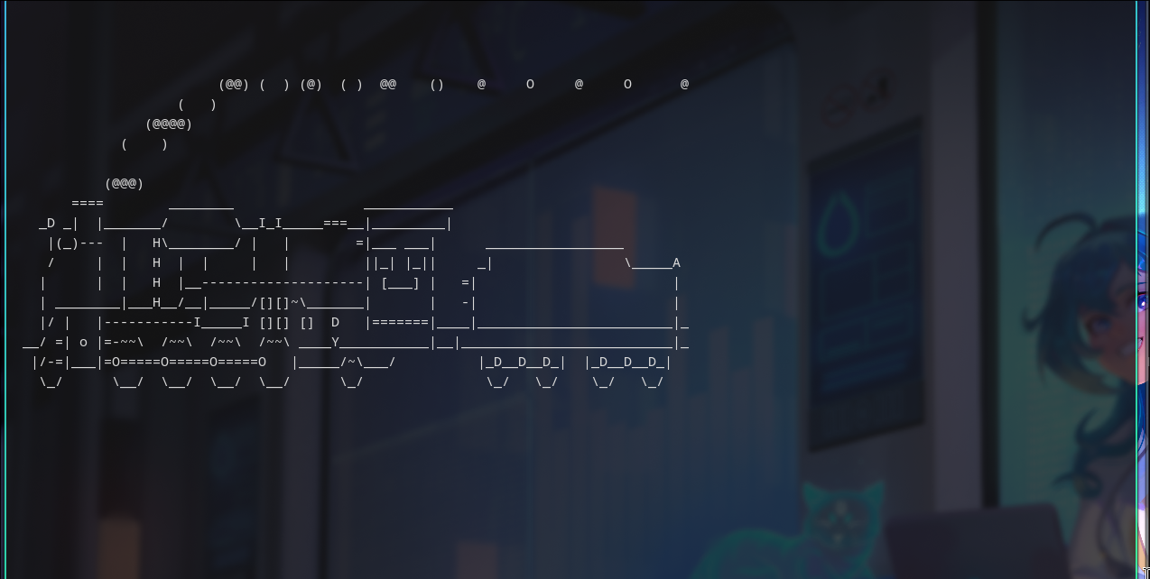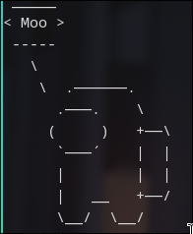

# sudo -s

Interpretation: Change to sudo SHELL for the user

Output:

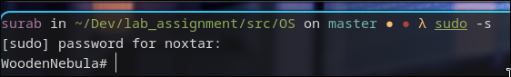

# exit

Interpretation: exits out of current shell environment

Output:

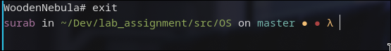

LAB 3 : BASH SCRIPTING

# basic scripting

Script:

#!/bin/bash

echo "Hello Bash Scripting!"

Interpretation:

#!/bin/bash specifies the bash interpreter

echo just prints out the string to stdout

It is necessary to chmod a+x basic.sh to execute it properly

Output:

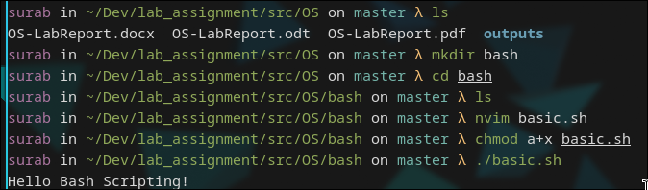

# Input

#!/bin/bash

read -p "Enter your name: " name

echo "Your name is $name"

Interpretation:

read is for inputting from stdin. read -p means to print while waiting for input and name is the variable to store the input into.

Output:

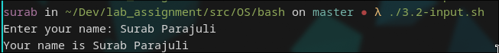

# Square

#!/bin/bash

read -p "Enter a number: " number

square=$(($number*$number))

echo "Square is $square"

Interpretation:

square is variable for storing result of number*number. Here, the $(()) tells the interpreter to interpret the result as a mathematical operation.

Output:

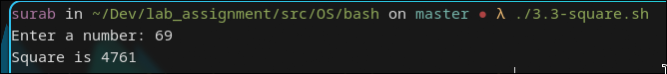

# Branching

#!/bin/bash

read -p "Enter a number: " number

remainder=$(($number%2))

if [[ ($number == 0) ]]; then

echo "The number is Zero."

elif [[ ($remainder == 0) ]]; then

echo "The number is Even."

else

echo "The number is Odd."

fi

Interpretation:

if is branching statement followed by [[ condition ]]; then. elif is else-if and the ending is fi. The above script reads a number and checks if its even or odd or zero

Output:

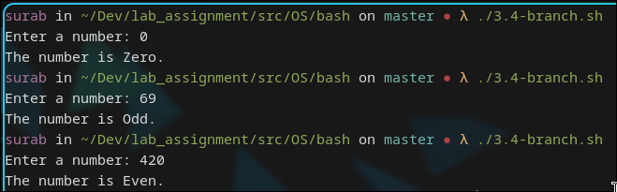

# for-loop

#!/bin/bash

echo "Printing 0-9"

for ((i = 0; i < 10; i++)); do

echo -n "$i "

done

echo

Interpretation:

for is looping statement followed by (( init; condition; statement )); do. The for loop is closed by done. The above script prints number from 0 to 9 in a single line, as denoted by echo -n

Output:

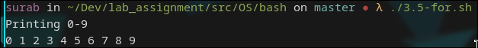

# while-loop

#!/bin/bash

echo "Printing 0-9"

i=0

while (( i < 10 )); do

echo -n "$i "

i=$(($i+1))

done

echo

Interpretation:

while is looping statement followed by (( condition)); do. Initialization has to be done separately. The while loop is also closed by done.

Output:

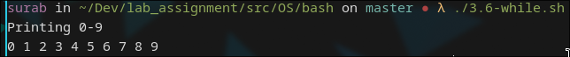

# directory manipulation

#!/bin/bash

mkdir arch

cd arch

touch arch.txt

echo "I use Arch btw." > arch.txt

cat arch.txt

cd ..

Interpretation:

The above script shows basic directory manipulation through bash script. It creates a dir named arch, cd’s into it and writes “I use Arch btw.” to a file named arch.txt and cats it.

Output:

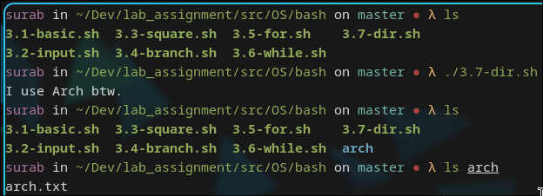

# while-dir

#!/bin/bash

count=10

i=1

should_make_dir=true

while $should_make_dir; do

new_dir="arch""$i"

mkdir $new_dir

cd $new_dir

echo "$i. I use Arch btw." > arch.txt

cat arch.txt

if (( i >= count )); then

should_make_dir=false;

fi

((i++))

done

Interpretation:

The script makes a new directory named archi where i is the current loop iteration. cd’s into it and writes a file arch.txt. This is repeated for 10 times.

Output:

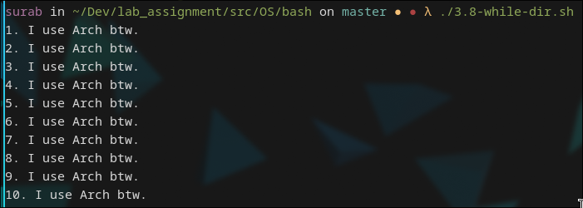

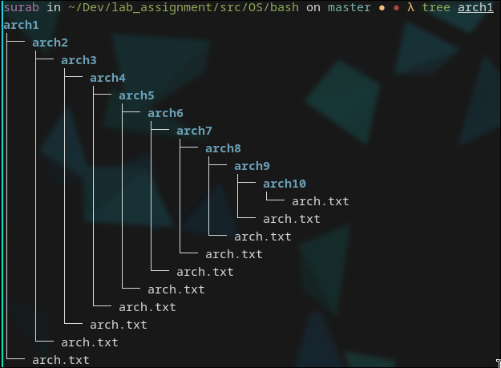

# commands

#!/bin/bash

lsusb > lsusb.txt

lshw -html > lshw.html

Interpretation:

Runs the command and redirects the output to files

Output:

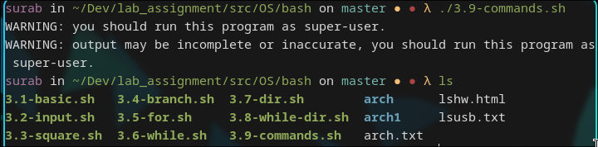

# system update

#!/bin/bash

sudo pacman -Syy

sudo pacman -Syyu

Interpretation:

Updates the package list and updates installed packages

Output:

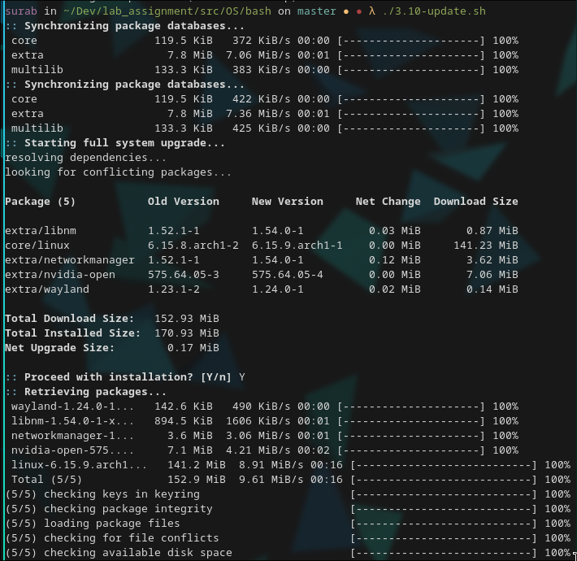

LAB 4 : PROCESSES

# print

Code:

#include <stdio.h>

int main(int argc, char *argv[]) {

printf("Hello World! This is printed through print syscall.");

}

Interpretation:

print syscall used in printf

Output:

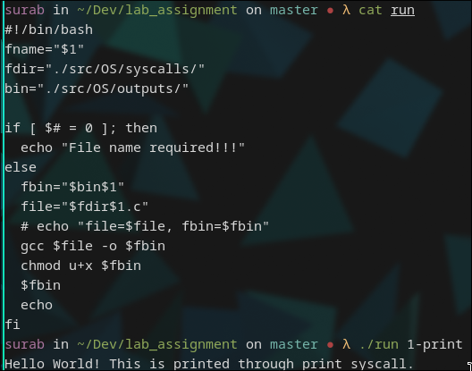

# fork

Code:

#include <stdio.h>

#include <unistd.h>

int main(int argc, char *argv[]) {

if (fork() == 0) { printf("Child Process!\n"); }

else { ("Parent Process!\n"); }

printf("Hello Arch Linux!\n");

}

Interpretation:

A program for creating child process from a parent process using function fork().

Output:

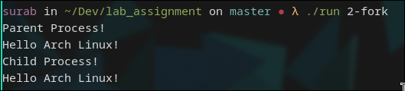

# pid

Code:

#include <stdio.h>

#include <unistd.h>

int main(int argc, char *argv[]) {

int child_pid = fork();

if (child_pid == 0) { printf("[%d] Child Process! PPID = %d\n", getpid(), getppid()); }

int child_pid_2 = fork();

if (child_pid_2 == 0) { printf("[%d] Child Process! PPID = %d\n", getpid(), getppid()); }

return 0;

}

Interpretation:

A simple program for demontration of fork() function which is used to create a child process from parent process.

Output:

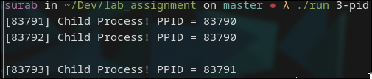

# execute

Code:

#include <stdio.h>

#include <unistd.h>

int main(int argc, char *argv[]) {

const char path[] = "/home/noxtar/Dev/lab_assignment/src/OS/outputs/1-print";

char *args[] = {"src/OS/outputs/1-print", "", "", NULL};

args[0] = "src/OS/outputs/1-print";

if (fork() == 0) {

printf("Child Process:\n");

printf("PID: %d\n", getpid());

printf("PPID: %d\n", getppid());

printf("Executing another c program\n");

execve(path, args, NULL);

} else { printf("Parent Process : id = %d\n", getpid()); }

}

Interpretation:

A program for demontrating execve() function which causes the program that is currently being run by the calling process to be replaced with a new program, with newly initialized stack, heap, and (initialized and uninitialized) data segments.

Output:

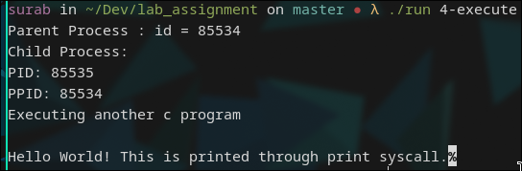

LAB 5 : THREADS

# basic

Code:

#include <pthread.h>

#include <stdio.h>

#include <time.h>

void *show(void *u) { printf("New thread\n"); }

int main() {

pthread_t tid;

time_t t;

time(&t);

printf("\nThis program has been written at (date and time): %s", ctime(&t));

pthread_create(&tid, NULL, &show, NULL);

printf("Main thread\n");

pthread_join(tid, NULL);

return 0;

}

Interpretation:

Creating new thread using pthread_create() function and executing a user-defined function show().

Output:

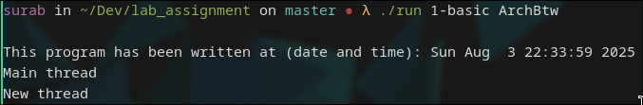

# multi-thread

Code:

#include <pthread.h>

#include <stdio.h>

#include <time.h>

#include <unistd.h>

int g_time = 1;

void *sleep_a(void *u) {

printf("\nNew Thread");

g_time += 5;

printf("\nSleeping for %d seconds", g_time);

sleep(g_time);

printf("\nSlept for %d seconds", g_time);

}

void *sleep_b(void *u) {

printf("\nOld Thread");

g_time += 2;

printf("\nSleeping for %d seconds", g_time);

sleep(g_time);

printf("\nSlept for %d seconds", g_time);

}

int main() {

pthread_t tid, tid2;

time_t t;

time(&t);

printf("\nThis program has been written at (date and time): %s", ctime(&t));

pthread_create(&tid, NULL, &sleep_a, NULL);

pthread_create(&tid2, NULL, &sleep_b, NULL);

printf("\nMain thread\n");

pthread_join(tid, NULL);

pthread_join(tid2, NULL);

}

Interpretation:

The pthread_join() function waits for the thread specified by thread to terminate. If that thread has already terminated, then pthread_join() returns immediately.

Output:

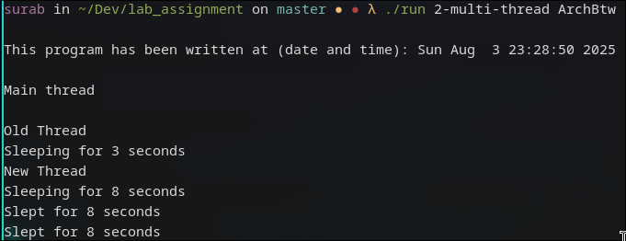

# thread-process

Code:

#include <pthread.h>

#include <stdio.h>

#include <stdlib.h>

#include <time.h>

#include <unistd.h>

void *show(void *u) {

int pid;

printf("\n[%d]->[%d] : Old Thread ", getppid(), getpid());

}

int main() {

int pid;

pthread_t tid;

pthread_t tid_child;

time_t t;

time(&t);

printf("\nThis program has been written at (date and time): %s", ctime(&t));

pthread_create(&tid, NULL, &show, NULL);

printf("\n[%d]->[%d] : Main thread", getppid(), getpid());

pid = fork();

if (pid == 0) {

printf("\n[%d]->[%d] : Child Process", getppid(), getpid());

exit(0);

}

pthread_join(tid, NULL);

return 0;

}

Interpretation:

Creating thread and creating its child process

Output:

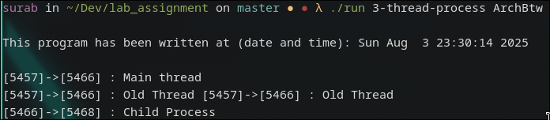

# thread-arguement

Code:

#include <pthread.h>

#include <stdio.h>

#include <stdlib.h>

#include <time.h>

#include <unistd.h>

int global;

void square() { global = global * global; }

void cube() { global = global * global * global; }

void *calculate(void *choice) {

int *id_ptr, taskid;

sleep(1);

id_ptr = (int *)choice;

taskid = *id_ptr;

printf("\nEnter a number: ");

scanf("%d", &global);

if (taskid == 0) {

square();

printf("\nthe square is %d: \n", global);

} else if (taskid == 1) {

cube();

printf("\nthe cube is %d: \n", global);

}

pthread_exit(NULL);

}

int main() {

pthread_t threads;

int *choice = malloc(sizeof(int *));

int rc;

time_t t;

time(&t);

printf("\nThis program has been writen at (date and time): %s", ctime(&t));

printf("\nEnter 0 for square and 1 for cube number: ");

scanf("%d", choice);

printf("Creating thread \n");

rc = pthread_create(&threads, NULL, calculate, (void *)choice);

if (rc) {

printf("ERROR; return code from pthread_create() is %d\n", rc);

exit(-1); }

pthread_exit(NULL);

}

Interpretation:

Demonstration of creating thread by passing function and its argument as parameter to the pthread_create() function.

O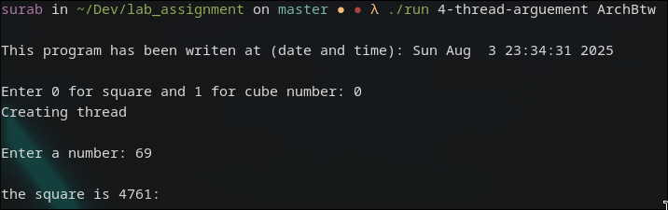utput:

LAB 6 : SCHEDULING

# Algorithms

Code:

#include <stdio.h>

#include <stdlib.h>

struct process {

int pid, AT, BT, WT, TAT;

};

struct process a[10];

int queue[100];

int front = -1;

int rear = -1;

void inputArrivalTime(int n, int *arrivalTime);

void inputBurstTime(int n, int *burstTime, int *p);

void swap(int *x, int *y);

void sortingFCFS(int *p, int n, int *arrivalTime, int *burstTime);

void sortingSJF(int n, int *at, int *bt, int *p);

float calculateAvgTATime(int *TATime, int n);

float calculateAvgWaitingTime(int *WaitingTime, int n);

void FCFS(int n, int *TATime, int *arrivalTime, int *burstTime,

int *waitingTime, int *p);

void SJF(int n, int *TATime, int *arrivalTime, int *burstTime, int *waitingTime, int *p);

void SRTN(int n);

void insert(int n);

int delete();

void RR(int n);

void inputArrivalTime(int n, int *arrivalTime) {

for (int i = 0; i < n; ++i)

scanf("%d", (arrivalTime + i));

}

void inputBurstTime(int n, int *burstTime, int *p) {

for (int i = 0; i < n; ++i) {

scanf("%d", (burstTime + i));

p[i] = i + 1;

}

}

void swap(int *x, int *y) {

int temp = *x;

*x = *y;

*y = temp;

}

// sorting arrivalTime,burstTime, and process according to at

void sortingFCFS(int *p, int n, int *arrivalTime, int *burstTime) {

int temp;

for (int i = 0; i < n; i++) {

for (int j = i + 1; j < n; j++) {

if (arrivalTime[i] > arrivalTime[j]) {

swap(&p[i], &p[j]);

swap(&arrivalTime[i], &arrivalTime[j]);

swap(&burstTime[i], &burstTime[j]);

}

}

}

}

float calculateAvgTATime(int *TATime, int n) {

float average, sum;

sum = 0;

for (int i = 0; i < n; ++i)

sum += *(TATime + i);

average = sum / n;

return average;

}

float calculateAvgWaitingTime(int *WaitingTime, int n) {

float average, sum;

sum = 0;

for (int i = 0; i < n; ++i)

sum += *(WaitingTime + i);

average = sum / n;

return average;

}

void sortingSJF(int n, int *at, int *bt, int *p) {

for (int i = 0; i < n; i++) {

for (int j = i + 1; j < n; j++) {

/* sort the process having less arrival*/

if (at[i] > at[j]) {

swap(&p[i], &p[j]);

swap(&at[i], &at[j]);

swap(&bt[i], &bt[j]);

} /* if two processes have the same arrival time than sort them having

less burst time */

else if (at[i] == at[j]) {

if (bt[i] > bt[j]) {

swap(&p[i], &p[j]);

swap(&at[i], &at[j]);

swap(&bt[i], &bt[j]);

}

}

}

}

}

void insert(int n) {

if (front == -1)

front = 0;

rear = rear + 1;

queue[rear] = n;

}

int delete() {

int n;

n = queue[front];

front = front + 1;

return n;

}

void FCFS(int n, int *TATime, int *arrivalTime, int *burstTime,

int *waitingTime, int *p) {

float avgWaiting, avgTA;

int *completionTime = malloc(n * sizeof(int *));

int temp;

// sorting at,bt, and process according to at

sortingFCFS(p, n, arrivalTime, burstTime);

// FOR CALCULATION OF COMPLETION TIME

/* calculating 1st ct */

completionTime[0] = arrivalTime[0] + burstTime[0];

/* calculating 2 to n ct */

for (int i = 1; i < n; i++) {

// when proess is ideal in between i and i+1

temp = 0;

if (completionTime[i - 1] < arrivalTime[i]) {

temp = arrivalTime[i] - completionTime[i - 1];

}

completionTime[i] = completionTime[i - 1] + burstTime[i] + temp;

}

// FOR CALCULATION OF TURNAROUND TIME AND WAITING TIME

printf("\nProcess\t\tArrival Time\t\tBurst Time\t\tCompletion "

"Time\t\tTurnAround Time\t\tWaiting Time");

for (int i = 0; i < n; ++i) {

*(TATime + i) = *(completionTime + i) - *(arrivalTime + i);

*(waitingTime + i) = *(TATime + i) - *(burstTime + i);

printf("\nP[%d]\t\t\t%d\t\t\t%d\t\t\t%d", *(p + i), *(arrivalTime + i),

*(burstTime + i), *(completionTime));

}

avgWaiting = calculateAvgWaitingTime(waitingTime, n);

avgTA = calculateAvgTATime(TATime, n);

printf("\nThe average waiting time is %.3f\n", avgWaiting);

printf("The average TurnAround time is %.3f\n", avgTA);

}

void SJF(int n, int *TATime, int *arrivalTime, int *burstTime, int *waitingTime, int *p) {

float avgWaiting, avgTA;

int *completionTime = malloc(n * sizeof(int *));

int pos;

int min = 1000;

/* SORTING PROCESS ACCORDING TO THE ARRIVAL TIME */

sortingSJF(n, arrivalTime, burstTime, p);

/* FOR CALCULATION OF COMPLETION TIME */

/* calculating 1st ct */

completionTime[0] = arrivalTime[0] + burstTime[0];

/* calculating 2 to n ct */

for (int i = 1; i < n; i++) {

for (int j = i; j < n; j++) {

if (arrivalTime[j] <= completionTime[i - 1]) {

if (burstTime[j] < min) {

min = burstTime[j];

pos = j;

}

}

}

/* when you get less burst time process, swap p, arrivalTime, burstTime

arrivalTime position 2, and when getting 2nd less burst time swap

arrivalTime position 3rd and so on. */

swap(&p[i], &p[pos]);

swap(&arrivalTime[i], &arrivalTime[pos]);

swap(&burstTime[i], &burstTime[pos]);

min = 1000;

completionTime[i] = completionTime[i - 1] + burstTime[i];

}

// FOR CALCULATION OF TURNAROUND TIME AND WAITING TIME

printf("\nProcess\t\tArrival Time\t\tBurst Time\t\tCompletion "

"Time\t\tTurnAround Time\t\tWaiting Time");

for (int i = 0; i < n; ++i) {

*(TATime + i) = *(completionTime + i) - *(arrivalTime + i);

*(waitingTime + i) = *(TATime + i) - *(burstTime + i);

printf("\nP[%d]\t\t\t%d\t\t\t%d\t\t\t%d", *(p + i), *(arrivalTime + i),

*(burstTime + i), *(completionTime));

}

avgWaiting = calculateAvgWaitingTime(waitingTime, n);

avgTA = calculateAvgTATime(TATime, n);

printf("\nThe average waiting time is %.3f\n", avgWaiting);

printf("The average TurnAround time is %.3f\n", avgTA);

}

void SRTN(int n) {

int ari[10], bur[10], total = 0, i, j, small, temp, procs[100], k,

waiting[10], finish[10];

float tavg = 0.0, wavg = 0.0;

printf("Enter the arrival time: ");

for (i = 0; i < n; i++) {

scanf("%d", &ari[i]);

}

printf("Enter the burst time: ");

for (i = 0; i < n; i++) {

scanf("%d", &bur[i]);

waiting[i] = 0;

total += bur[i];

}

for (i = 0; i < n; i++) {

for (j = i + 1; j < n; j++) {

if (ari[i] > ari[j]) {

temp = ari[i];

ari[i] = ari[j];

ari[j] = temp;

temp = bur[i];

bur[i] = bur[j];

bur[j] = temp;

}

}

}

for (i = 0; i < total; i++) {

small = 3200;

for (j = 0; j < n; j++) {

if ((bur[j] != 0) && (ari[j] <= i) && (bur[j] < small)) {

small = bur[j];

k = j;

}

}

bur[k]--;

procs[i] = k;

}

k = 0;

for (i = 0; i < total; i++) {

for (j = 0; j < n; j++) {

if (procs[i] == j) {

finish[j] = i;

waiting[j]++;

}

}

}

for (i = 0; i < n; i++) {

printf("\nP[%d]\t\t\t%d\t\t\t%d\t\t\t%d\t\t\t%d", i + 1, ari[i], waiting[i],

finish[i] + 1, (((finish[i] + 1))));

wavg = wavg + (((finish[i] + 1) - waiting[i]) - ari[i]);

tavg = tavg + ((finish[i] - ari[i]) + 1);

}

printf("\n\nThe average waiting time is %.3f\n", (wavg / n));

printf("The average TurnAround time is %.3f\n", (tavg / n));

}

void RR(int n) {

int TQ, p, TIME = 0;

int temp[10], exist[10] = {0};

float total_wt = 0, total_tat = 0, Avg_WT, Avg_TAT;

printf("Enter the arrival time: ");

for (int i = 0; i < n; i++) {

scanf("%d", &a[i].AT);

a[i].pid = i;

}

printf("Enter the burst time: ");

for (int i = 0; i < n; i++) {

scanf("%d", &a[i].BT);

temp[i] = a[i].BT;

}

printf("Enter the time quantum: ");

scanf("%d", &TQ);

insert(0);

exist[0] = 1;

while (front <= rear) {

p = delete();

if (a[p].BT >= TQ) {

a[p].BT = a[p].BT - TQ;

TIME = TIME + TQ;

} else {

TIME = TIME + a[p].BT;

a[p].BT = 0;

}

for (int i = 0; i < n; i++) {

if (exist[i] == 0 && a[i].AT <= TIME) {

insert(i);

exist[i] = 1;

}

}

// if process is completed

if (a[p].BT == 0) {

a[p].TAT = TIME - a[p].AT;

a[p].WT = a[p].TAT - temp[p];

total_tat = total_tat + a[p].TAT;

total_wt = total_wt + a[p].WT;

} else {

insert(p);

}

}

Avg_TAT = total_tat / n;

Avg_WT = total_wt / n;

// printing of the answer

printf("\nProcess\t\tArrival Time\t\tBurst Time\t\tTurnAround "

"Time\t\tWaiting Time");

for (int i = 0; i < n; i++) {

printf("\nP[%d]\t\t\t%d\t\t\t%d\t\t\t%d\t\t\t%d", a[i].pid, a[i].AT,

a[i].BT, a[i].TAT, a[i].WT);

}

printf("\n\nThe average waiting time is %.3f\n", Avg_WT);

printf("The average TurnAround time is %.3f\n", Avg_TAT);

}

int main() {

int choice;

while (1) {

printf("\nProcess scheduling algorithm: \n 1. First Come First Serve \n 2.

Shortest Job First (non-preemptive) \n 3. Shortest Remaining Time

Next(preemptive) \n 4. Round Robin \n 5. Exit \n");

printf("Enter your choice: ");

scanf("%d", &choice);

int n;

float avgWaiting, avgTA;

if (choice == 5) {

printf("Terminating program!!\n");

exit(0);

}

printf("Enter the number of process: ");

scanf("%d", &n);

int *arrivalTime = malloc(n * sizeof(int *));

int *burstTime = malloc(n * sizeof(int *));

int *waitingTime = malloc(n * sizeof(int *));

int *TATime = malloc(n * sizeof(int *));

int *Process = malloc(n * sizeof(int *));

system("clear");

switch (choice) {

case 1:

printf(" >>>>First Come First Serve<<<<\n");

printf("Number of process: %d\n", n);

printf("Enter the arrival time : ");

inputArrivalTime(n, arrivalTime);

printf("Enter the burst time : ");

inputBurstTime(n, burstTime, Process);

FCFS(n, TATime, arrivalTime, burstTime, waitingTime, Process);

printf("\n===========================================================\n\n");

break;

case 2:

printf(" >>>>Shortest Job First (non-preemptive)<<<<\n");

printf("Number of process: %d\n", n);

printf("Enter the arrival time : ");

inputArrivalTime(n, arrivalTime);

printf("Enter the burst time : ");

inputBurstTime(n, burstTime, Process);

SJF(n, TATime, arrivalTime, burstTime, waitingTime, Process);

printf("\n==============================================================="

"======================\n\n");

break;

case 3:

printf(" >>>>Shortest Remaining Time Next(preemptive)<<<<\n");

printf("Number of process: %d\n", n);

SRTN(n);

printf("\n==============================================================="

"======================\n\n");

break;

case 4:

printf(" >>>>Round Robin<<<<\n");

printf("Number of process: %d\n", n);

RR(n);

printf("\n==============================================================="

"======================\n\n");

break;

default:

printf("\n==============================================================="

"======================\n\n");

printf("Please enter correct options!\n\n");

}

}

}

Output:

